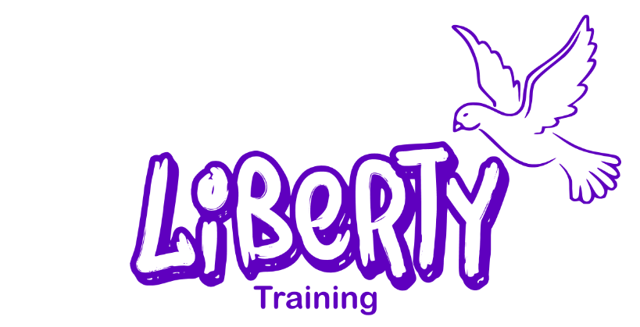

Charges and Remissions Policy

Reviewed: | 12 months
Approved by Directors: | April 2022
To be reviewed: | April 2023
Version | 1

NAME OF 1st REVIEWER | Michelle Smith
NAME OF 2nd REVIEWER | Jojo Rassekh

Contents

Policy Statement 2
Admissions 2
Examinations & courses 2
Equipment & Materials 2
Travel 2
Free School Meals 2
Enrichment Activities 3
Residential Trips 3
Damage to Property & Breakages 3
Bursaries 4
Charitable Grants 4
Linked Policies 4
Appendix 4

Policy Statement

The directors recognise the valuable contribution that a wide range of additional activities including trips and residential experiences can make towards learners’ personal and social education. The College aims to promote and provide such opportunities both as part of a broad and balanced curriculum and as additional optional activities.

The principle at Liberty Training shall be that no learner should be prevented from undertaking any course or taking part in any essential activity because of a learner, parent, or carer’s ability to pay.

Admissions

There is no charge for admissions.

Examinations & courses

There is no charge for examinations or courses.

Equipment & Materials

There is no charge for equipment and materials. All learners will be provided with the necessary stationary, materials and equipment required for them to learn at Liberty.

Travel

Liberty Training does not charge for travel provided to or from the college or for any enrichment or residential activity.

Learners with an EHCP who is unable to use public transport may be entitled to taxis funded through the local authority.

Where a learner is entitled to a bursary, bursary funding may be used to reimburse the cost of public transport (please see the section Bursaries below). The learner must hand their bus or train ticket to reception on arrival so that it can be photocopied. The learners will be reimbursed in cash when they leave (or by bank transfer where this has been agreed)

Free School Meals

There is no charge for learners who are entitled to Free School Meals. Free School Meals application forms are sent out with admissions packs before a learner begins attending Liberty and can be obtained from reception after they join the college.

Our canteen, The Grub Hub, offers ‘meal deals’ to learners who are not in receipt of free school meals. These are charged at the same price as a free school meal (as set by the Local Authority).

The Grub Hub also offers a range of meals, snacks and drinks that learners can purchase.

Learners who are not entitled to Free School Meals may be entitled to a bursary (please see the section Bursaries below).

Learners who are not entitled to free school meals but are unable to pay for lunch due to financial hardship or forgetting their lunch money will be required to complete an Emergency Sustenance Form, and lunch will be provided for them. The Directors will assess whether this money should be repaid on a case-by-case basis, depending on the individual circumstances of the learner.

Enrichment Activities

Liberty Training is committed to providing activities that enhance the curriculum and extend learners learning opportunities. Liberty will fund these activities and there will be no cost to learners, parents or carers. Where a learner is entitled to a bursary, bursary funding may be used to cover the cost of the enrichment activity (please see the section Bursaries below).

Residential Trips

Liberty Training is proud to offer learners the opportunity to attend residential trips to further assist with their education and personal & social development. Liberty will fund these activities and there will be no cost to learners, parents or carers. Where a learner is entitled to a bursary, bursary funding may be used to cover the cost of the enrichment activity (please see the section Bursaries below).

However, due to the high costs of residential trips, learners, parents or carers may be asked to pay a small deposit to secure the learners place on the trip and to avoid non-attendance on the day. This deposit will be returned to the learner as spending money for the trip.

Where a learner does not attend the residential trip and insufficient notice has been given for Liberty to cancel their place and obtain a refund, the deposit will be used as a partial contribution to cover the cost of the learner’s place.

Damage to Property & Breakages

Where college property has been wilfully damaged by a learner, the college may charge those responsible for some or all of the cost of repair or replacement.

Where property belonging to a third party has been damaged by a learner, and the college has been charged, the college may charge some or all of the cost to those responsible.

Whether or not these charges will be made will be decided by the Directors and dependent on the situation.

Bursaries

Learners experiencing financial hardship may be entitled to help with costs under the college’s bursary scheme. Application forms are sent out with admissions packs before a learner begins attending Liberty and can be obtained from reception after they join the college.

Learners, parents and carers are encouraged to discuss any financial difficulties with their tutor. All applications for help with funding will be treated as strictly confidential.

Please see the Bursary Funding and CIC Grant poster which is displayed throughout the college (appendix 1) and the college’s Bursary Policy for more detailed information.

Charitable Grants

Learners at Liberty Training may be able to access charitable grants of up to £500 through our sister organisation, Liberty For All CIC.

The charitable grants are provided by Colyer Fergusson Charitable Trust on a case-by-case basis and can be used to support individual disadvantaged young people to navigate the journey into employment and adulthood.

You can find more information at http://www.cfct.org.uk/grants-to-individuals/ and on the Bursary Funding and CIC Grant poster which is displayed throughout the college (appendix 1).

Linked Policies

- Bursary Policy

Appendix

Appendix 1:

